Reading Activity 12.1.2021
WALT: Explore themes
Reading: King of the Sky by Nicola Davies

Watch the following video:
https://classroom.thenational.academy/lessons/to-generate-and-explore-themes-64wk8c
Remember to write in full sentences please.
- Does friendship bring happiness?

- Describe Mr. Evans 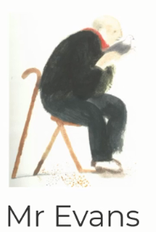

- Have you enjoyed working on King of the Sky?

- What book are you currently reading? What is your book about?

