Math Activity 12.1.2021
WALT: consolidate our 2,4 and 8 times tables
Watch this video https://vimeo.com/485432791
You will need something to write on whilst you watch the video!
Make sure that you pause the video (when asked to do so) to solve the answers.
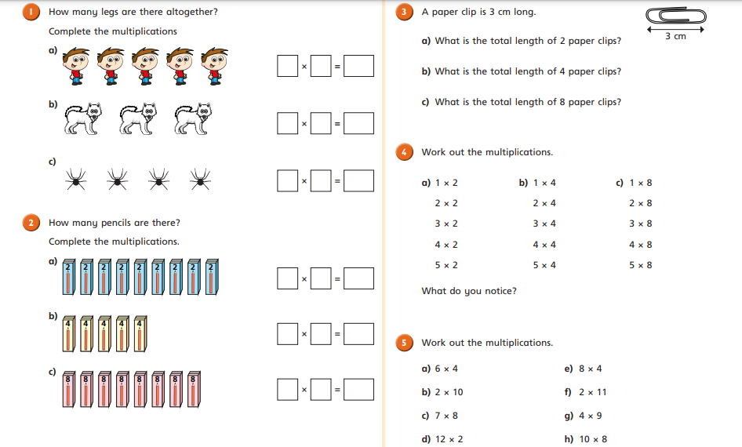

Answer sheet

1a
1b
1c
2a
2b
2c
3a
3b
3c
4a
1x2=
2x2=
3 x2=
4x2=
5x2=

4b
1x4=
2x4=
3x4=
4x4=
5x4=

4c
1x8=
2x8=
3x8=
4x8=
5x8=
What do you notice?

5. Work out the multiplication questions
5a. 6x4=
5b. 2x10=
5c. 7x8=
5d. 12 x2=
5e. 8x4=
5f. 2x11=
5g. 4x9=
5h. 10x8=

