English activity 12.1.2021
English lesson
Walt: understand new vocabulary

The Day the crayons quit
Video link:
https://classroom.thenational.academy/lessons/to-develop-a-rich-understanding-of-words-associated-with-negative-emotions-chhp8c

- Describe what is happening in this picture? 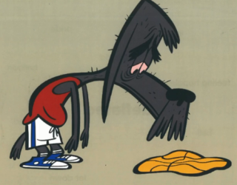

- In your own words, try to describe a synonym?

- What does the word deflated mean?

- Describe what is happening in this picture?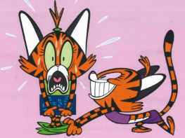
I can see……………………

I notice a……………..

I think that the character is feeling…

I think that the atmosphere is……………..
- What does the word humiliated mean?
- Describe what is happening in this picture?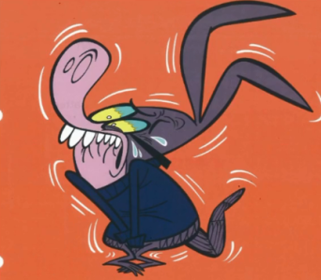
I can see……………………

I notice a……………..

I think that the character is feeling…

I think that the atmosphere is……………..

- What new vocabulary did you learn today?

