

Currency

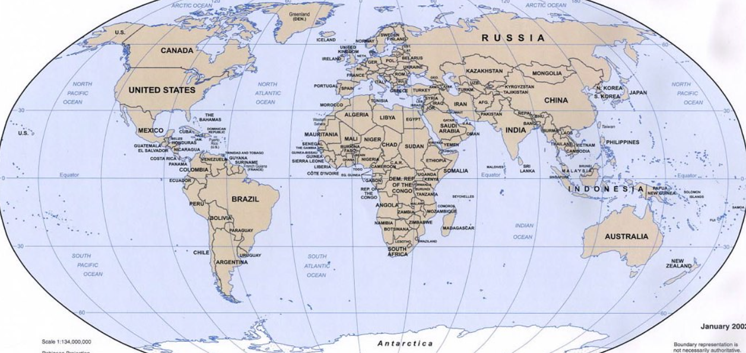

*Source: Nathan Hughes Hamilton*

Locate each country on a world map. Which continent is each part of? Choose another country from the map and find out its currency.

Each country has its own currency. This is the system of money it uses. The currency used in the UK is called pound sterling. Find out the currency of the following countries:

|  |  |
| --- | --- |
| **Country** | **Currency** |
| France |  |
| USA |  |
| China |  |
| Uganda |  |
| Australia |  |

Locate Antarctica. Why does Antarctica not have an official currency?