Have you got Maths Eyes?
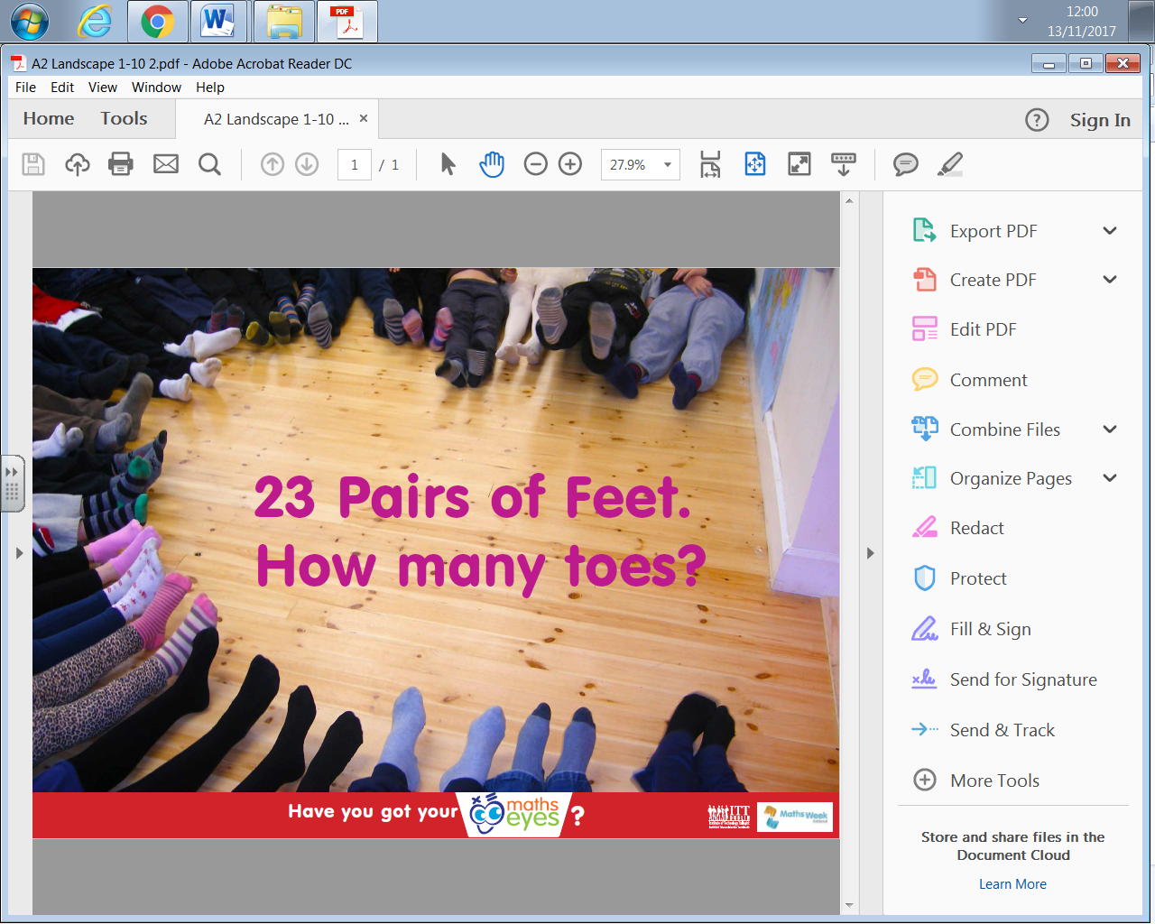
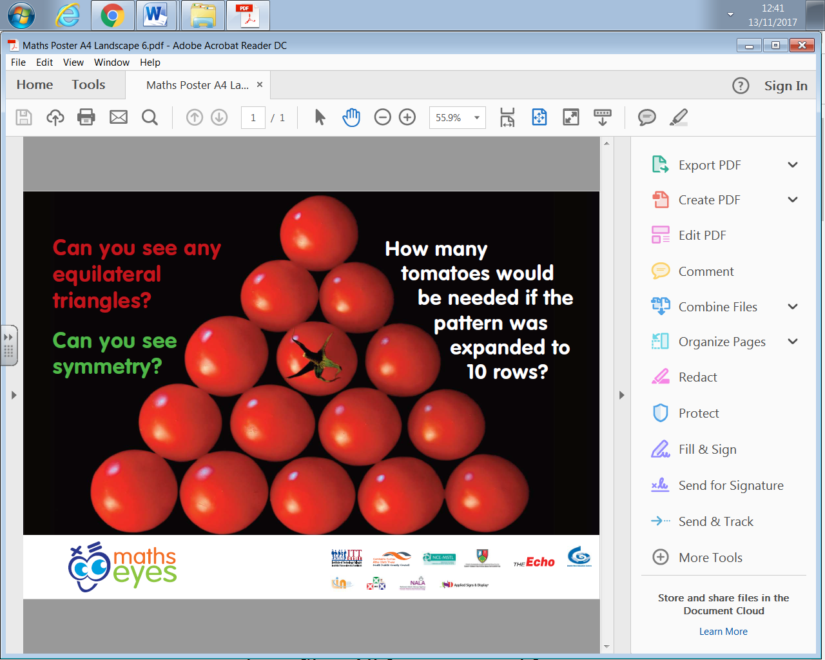
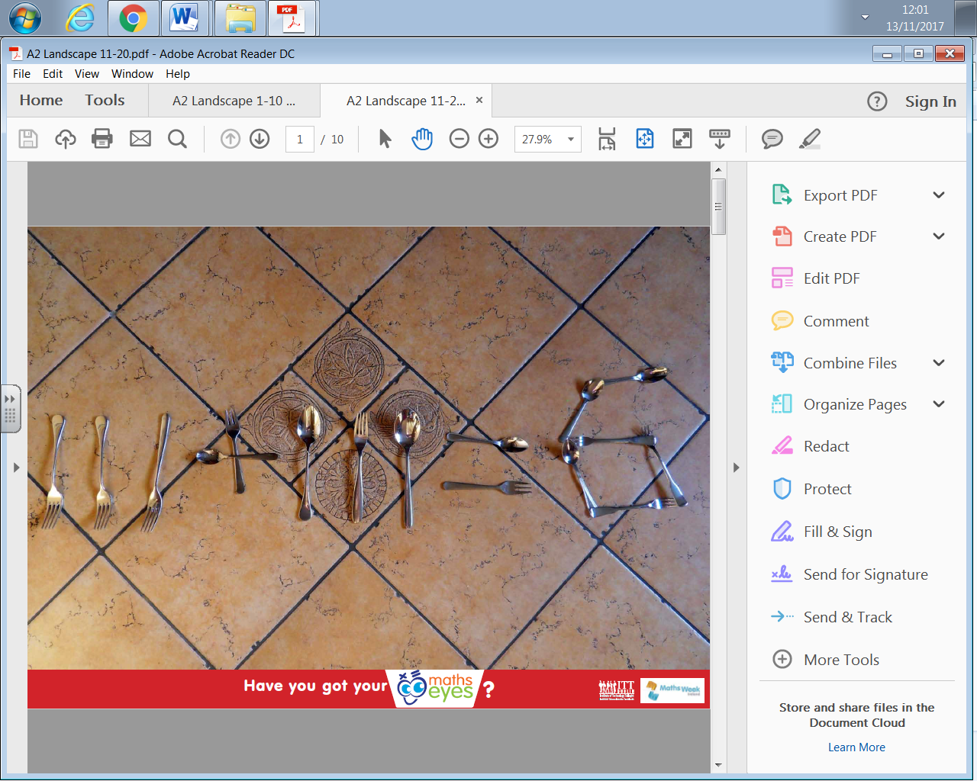
Can you see maths around you?

We are running a competition for you to prove if you have maths eyes.
Find a real life opportunity that shows maths and capture it in a photo. Add your maths question and send to your Maths Ambassadors. You can use Ipods in class or email to Miss Doyle with your question.
Two competitions
Solo / Independent entry – take a photo of something around you at school or local area. Enter with maths question
Family / Community Entry – with your family or a group take a photo of something which highlights the maths you can see in it
Keep your eyes peeled around school for brilliant examples!

